Unit 3: It was painted by a street artist.

Speaking: Talking about art

Grammar: Passives

Reading: A street artist

Warm-up
- What public art is near you?

Keep in mind: Art isn’t just about paintings and sculptures. Art includes music, dance, literature and much more.

High art versus low art…?
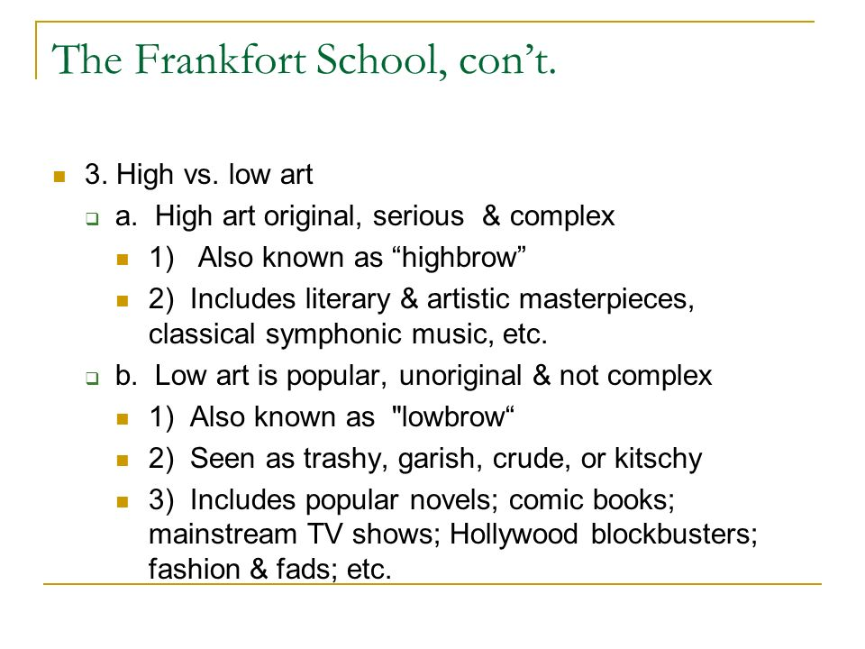

Vocabulary = find examples
- Opera = The Magic Flute by Mozart
- TIP: YouTube helps!

Grammar: Passives
- The Passive Voice
- Video Tutorial: https://www.youtube.com/watch?v=nkAyggAM1q4

Passives --> "Voice"
- Active Voice = Focus is on who performed the action
  - Aaron played the piano.
- Passive Voice = who performed the action is not important
  - The piano was played by Aaron.
  - In short, who/what performed an action is less emphasized.
- Passives are only one way to express ideas in English.
- Why passives? —> When we don’t know who or what performed an action…
  - Or it doesn’t matter given the context in speaking/ writing who or what performed an action.
  - We may also use passives to add variety to what we say and write.
- Problems with passives?
- Can be unclear (they take emphasis away from who/ what performs an action)
- More complicated grammatically— and may invite unneeded grammatical errors.
- Usually, using passives requires more words. When we communicate in speaking and in writing, it is best to be brief.

Grammar Explanation: https://www.ef.com/wwen/english-resources/english-grammar/passive-voice/

Reading

Conversation Questions

- How often do you go to art museums?
- Do you consider yourself to be artistic?
- How many forms of art can you name? What is your favourite form of art?
- Who is your favourite artist? Why do you like them so much?
- Do you think that art is important to society? Why?
- Have you ever tried drawing, painting, sculpting, or something else artistic?
- What is the most famous art in your country?
- What is traditional art like in your culture?
- What country do you think is the most creative?
- Do you have any artistic friends? What kinds of art do they create?

Think. Prepare. Record. Playback. Track your progress—and don’t forget to label everything.

